LAB 04: Maven intro

Ex 1: Maven Project Dependencies
For this exercise, you will prepare the Maven project for your course main project (you can work in groups, same group as in the course main project).
- Create a maven project with the name of your course main project (see course main project description).
- In src/main/java folder, create a Class with a main method, make sure you name your project using a namespace that reflects your team/company, for example: psu.se411.myprojectname
Example:
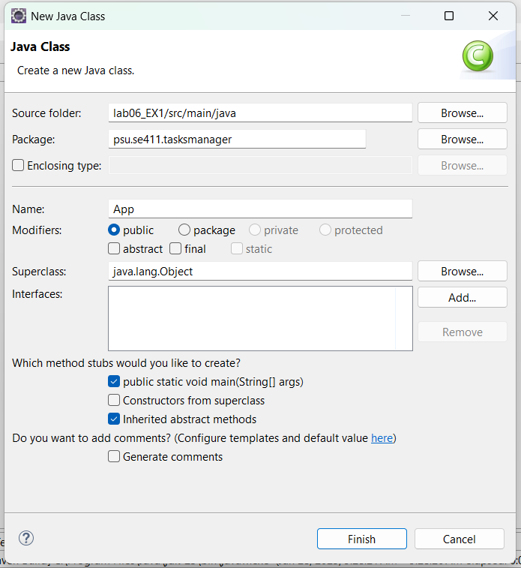

- Import JavaFX into your maven project by adding a dependency and a plugin:
Declaration of a dependency to JavaFX in pom.xml | - Add a dependencies section inside the project element  <project>  …........  <dependencies>  </dependencies>  </project>  - Add the JavaFx dependency inside the dependencies element:  <dependency>  <groupId>org.openjfx</groupId>  <artifactId>javafx-controls</artifactId>  <version>23</version>  </dependency>
Declaration of a JavaFX plugin in pom.xml | - Add a build section inside the project section.  <project>  …........  <dependencies>  </dependencies>  <build>  </build>  </project>  - Add a plugins section inside the build section:  <build>  <plugins>  </plugins>  </build>  - Add the JavaFX plugin that has the “run” goal. Make sure you change the package name and the main class name accordingly.  <plugin>  <groupId>org.openjfx</groupId>  <artifactId>javafx-maven-plugin</artifactId>  <version>0.0.8</version>  <configuration>  <mainClass>packageName.MainClass</mainClass>  </configuration>  </plugin>

3. Test your project by creating a very basic JavaFX application in your main class: Make your Main class inherit from the JavaFx Application class:

public class MainClass extends Application ..

Then implement the basic methods of a JavaFX Application: For Example:
public static void main(String[] args) {
launch();
}

@Override
public void start(Stage primaryStage) {
try {
primaryStage.setTitle("My Project");

primaryStage.show();

} catch (Exception e) {
e.printStackTrace();
}
}

4. Finally, execute the clean and javafx:run goals using Maven. The window should show up.

EX 2: Maven Site Plugin

Continue working of the same project.

You will add basic information to your project and generate a website as documentation:

- In pom.xml add the following elements:
- Add information about your project | <name>MyProject Name</name>  <description>This project is……  </description>  <url>https://yourProjectUrl.dom</url>
- Add information about the license of the product | <licenses>  <license>  <name>Apache License 2.0</name>  <url>https://www.apache.org/licenses/LICENSE-2.0</url>  </license>  </licenses>
- Add information about your company (here it is a team) | <organization>  <name>SE411-Tech-Company</name>  <url>https://mycompanyUrl.dom</url>  </organization>
- Add information about the developers (your team members) | <developers>  <developer>  <name>Salah Ahmed</name>  <email>salah.ahmed@domain.com</email>  </developer>  </developers>

- Generate the documentation website by running the basic site plugin: clean site
- Inside the target/site folder, you should find an index.html page. Open it by right-clicking -> open with -> system editor.
- (optional) open a generative AI tool (copilot, chatgpt, gemini, claude…) and find how you can improve your generated site by including other useful information.
END

